**Norfolk Punt Rules**

**Document Version**

01 - December 2015, digital copy of 2003 rules from website.

02 – December 2015, text corrections, proposed draft rule changes and rule

re-numbering.

02.1 – January 2016, AH revision of draft.

02.2 – January 2016 technical committee revision of draft.

02.3 – Feb 2016 AH revision of draft.

02.4 – March 2016 Revision following consultation with owners.

02.5 - March 2016 Revision following publication of draft.

02.6 – April 2016 Final Draft passed at E.G.M.

02.7 – Feb 2017 amended following rule changes at AGM.

02.8 - April 2017 inserted new total sail area figure

02.9 – January 2018 amend minimum weight rule following AGM.

**General**

The objective of the Norfolk Punt Class is to promote yacht racing on the

Norfolk & Suffolk Broads in vessels which derive from the traditional

marshmen’s working boats.

A Norfolk Punt is defined as a strongly built, light draught, partly decked

sailing craft, with pointed stem and stern, a centreboard and a nearly flat

bottom. The gunwale plan view being a fair curve, the sheerline flat with very

low freeboard.

The Punt Owners Association Honorary Secretary should be contacted for

clarification of these class rules by the association technical committee.

Any changes to these rules must be approved by the members of the Punt

Owners Association at a meeting of the Punt Owners Association held in

accordance with the constitution of the Punt Owners Association.

The Norfolk Punt shall be a class restricted by the following regulations:

**Hull**

**1. Hull Plan**

The hull shall be symmetrical athwartships and pointed at both the stem and

stern. ‘Pointed’ shall be defined as a subtended angle of no more than 80

degrees at the bow and a subtended angle of no more than 110 degrees at

the stern.

**2. Length**

The overall length shall not exceed 22’2” (6756 mm) and shall not be less

than 18’ (5486mm).

**3. Beam**

The overall beam including any rubbing strake of 2”(50mm) maximum width

from the sheerline shall not exceed 6’ (1829mm).

**4. Rocker**

Fore and aft rocker shall not exceed 6”(152mm) measured on the centreline

at points 1’6” (457mm) from either end of the boat. A line drawn from the base

of the stem head to the base of the stern post along the bottom centreline of

the boat shall be a fair curve.

**5. Rise of Floor**

Rise of floor at mid length shall not exceed 5” (127mm) at points 2’ (610mm)

and 90 degrees from the centreline.

**6. Depth of Hull**

Vertical depth of the hull at mid length cross section shall not exceed 15”

(381mm) measured from the sheerline to outside of the bottom (excluding

keelband if fitted).

**7. Decks**

The foredeck shall extend aft at least 4’ (1219mm) from the bow. The stern

deck shall extend forward at least 2’ (610mm) from the stern. The side deck

width shall be maximum 1’ (305mm) excluding rubbing strake and minimum 6”

(152mm). The cockpit shall be at least 6’ (1829mm) in length.

**8. Buoyancy**

It is the owner’s responsibility to ensure that a waterlogged boat will float

supporting the crew.

**9. Weight**

There is no minimum weight for the hull, however the hull shall be weighed and the weight recorded for handicapping purposes. The hull is weighed with all fittings that are permanently attached but not including the centreboard and rudder or rig and rigging. It is the owner’s responsibility to ensure that the hull is built with adequate structural strength.

**10. Longitudal Web**

A girder or web shall run along the centreline of the boat to include the

centreboard case and rudder box at least from a point below the forestay or

jib tack to the aft side of the rudder box. This girder/web must be adequately

braced from the mast step to the fixing point of the shrouds. The girder/web

should extend from the keel to the deck within the buoyancy tanks and

elsewhere be the height of the open part of the centreboard case, except that

it may be reduced in height aft of the centreboard case, it is the owners

responsibility to ensure that the hull is adequately reinforced to compensate

for the reduction in strength. Lightening holes may be drilled in the girder or

web but this must not affect the strength of the structure.

**11. Projections**

**11.1**

No fitting shall project outside the plan of the rubbing strake except a bowsprit

tube, this may project laterally beyond the rubbing strake but not forward of it.

**11.2**

The class will not carry racks as permanent or temporary fixings to the hull.

**12. Centreboard**

The centreboard shall be un-ballasted, fully retractable and removable from its

case.

**13. Rudder**

The rudder shall be housed inboard and easily removable from its case from

inside the boat. A rudder gantry shall not be permitted.

**Rig**

**15. Spars**

The mast, main boom, spinnaker booms and bowsprit may be of any material

and length, but at no time shall the bowsprit, including fittings, project more

than 7’ (2134mm) in front of the stem. A wishbone boom shall not be

permitted.

**16. Sails**

**16.1.**

Sail measurement points and definitions are as in World Sailing the

Equipment Rules of Sailing for 2017-2020, sail definitions section G, subsection

A (Tri-lateral sail).

**16.2.**

The sail area, excluding spinnaker, shall not exceed 22.0 square metres

**16.3.**

There shall be no restriction in length or number of battens.

**16.4.**

There shall be no restrictions on the sailcloth material.

**17. Measurement of Sails**

It is intended that the total area of the sails shall be measured using successive

triangulations and the following procedure:

The sail shall have sufficient tension applied to its edges so as to ensure that as

much as possible of the sail lies flat and the majority of the folds in the luff

disappear. Measurements shall be taken to the outside edges of the sails,

including ropes or wires. Zip fasteners and other devices should be measured

either open or closed in such a way that reflects the actual usable sail area when

set.

**17.1. Mainsail**

The battens are to be in place, but withdrawn sufficiently to allow the luff to be

straight as possible. The main triangle is then measured. The area of the leech is

measured by successive triangulation; the perpendicular of each triangle shall be

positioned at the maximum width of the segment, except that they shall be

positioned so that the perpendicular of the lower triangle shall not be less than

150mm.

If the lower part of the leech is straight the second triangle may be taken to meet

the leech at the upper end of the straight part to simplify calculations. If the edge

of the sail is curved the area is divided into triangles until the perpendicular of a

segment is less than 150mm. The area of the remaining segment is taken as 2/3

chord times width. If the edge of the sail is straight it shall be divided into

convenient triangles. The areas of the roaches on the luff and foot are measured

using the same method.

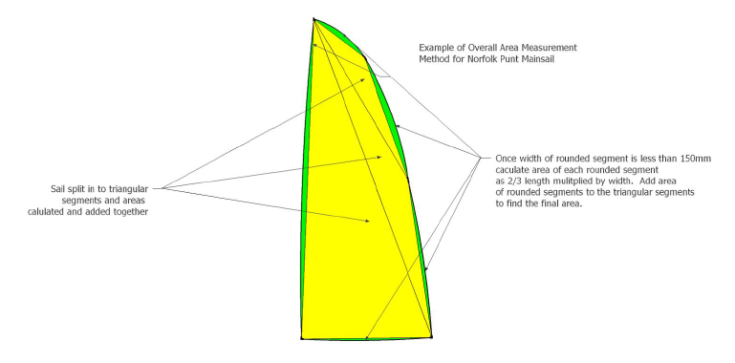

The measuring points at the corner of the sails shall be the intersection of the

continued smooth edges of the sail.

Any negative areas of the luff, foot and leech shall be subtracted from the total

area and any positive areas on the luff and foot shall be included.

**17.2. Jib**

The area is to be measured by successive triangulations using a similar method

to that used for the mainsail.

**17.3.**

All linear dimensions shall be taken to the nearest mm. The total area of each

sail shall, after addition of its components be rounded off to two decimal places

(0.01 square metre)

**17.4.**

The measured sail area shall be marked in indelible ink in figures of at least

51mm high on the tack of the jib and the clew of the mainsail at the time of

measuring.

**19. Spinnaker**

**19.1.**

The spinnaker shall be a three-cornered sail constructed of normal woven

sailcloth. No headboard, battens or other stiffening device, other than normal

woven cloth reinforcing is allowed.. There is no restriction on spinnaker sail

area.

**19.2.**

A bowsprit where fitted shall be retracted inboard except while the spinnaker

is set, or during hoisting or lowering thereof.

**19.3.**

Only one spinnaker may be carried in the boat in Punt Class races.

**20. Sail Numbers**

**20.1.**

Sail numbers shall be carried on the Mainsail in accordance with the ISAF

rules current at the time of measurement.

**20.2.**

Where sail numbers are carried on a spinnaker they must be the sail

number of the boat.

**21. Boat Name**

The name shall be submitted to the Punt Owners Association Honorary

Secretary for approval. Traditionally boats are named after birds or fish.

**22. Certificates and Registration**

**22.1.**

Plans for new designs or substantial/innovative alterations to existing

boats (hull/foils/rig/sailplan) shall be submitted to the Punt Owners

Association Honorary Secretary for approval by the association technical

committee prior to work being undertaken.

the deck.

**22.2.**

No boat shall be allowed to race in the class unless she has a valid

Measurement Certificate. This certificate shall be issued by the Owners'

Association Secretary on receipt from the Measurer of a completed

Measurement Form showing the boat conforms to Class Rules. Areas and

serial numbers of sails measured are to be recorded on the Measurement

Certificate.

**22.3.**

Any boat measured before 1997 (excepting no 84) is deemed to have

complied with the rules in force at the time she was measured. Any alteration

after 1997 shall comply with the rules current at the time of the alteration.

Cases of doubt regarding compliance with the Class Rules shall be referred

to the Punt Owners Association Honorary Secretary for approval by the

association technical committee.

**22.4.**

Any boat which has major repairs or modifications which could potentially

alter the boat’s performance must be re-measured by an approved class

measurer in accordance with the current class rules. Contact the Punt

Owners Association Honorary Secretary for clarification by the association

technical committee of repairs or modifications requiring re-measurement.

Where a boat has an existing feature not affected by the repair/modification,

which passed measurement at the time of the boat’s construction but which

would not now pass measurement under the current class rules, it will be

deemed to measure. However if this feature is affected by the repairs or

modifications contact the Punt Owners Association Honorary Secretary for

clarification by the association technical committee as to whether it should

be rebuilt to measure to current class rules.

**Appendix 1**

**Rules of the Hardchine Punt**

**1. General**

**1.1**

This appendix to the Norfolk Punt class rules provides a definition of the parameters

to be met for a Norfolk Punt to be eligible to race as a Hardchine Punt. All boats

complying with these rules will race using the same handicap (to be set by the Class

Association) and will be eligible for ‘Hardchine Punt’ trophies and prizes.

**1.2**

For a Norfolk Punt to be considered as a Hardchine Punt it must comply with the

rules in this appendix to the Norfolk Punt class rules. Where a measurement

parameter is covered in both the Norfolk Punt class rules and this appendix the rules

in this appendix take precedence. For rules not covered in this appendix the rules of

the Norfolk Punt class should be complied with.

**1.3**

If a Norfolk Punt does not comply with the rules in this appendix it may still race as a

Norfolk Punt as long as it complies with the Norfolk Punt class rules, but not for

Hardchine Punt trophies and prizes.

**1.4**

Any Hardchine hull built before May 2016 is deemed to have complied with the rules

in force at the time she was measured and will be eligible to race as a ‘Hardchine’

Norfolk Punt.

**2. Materials and Construction**

**2.1. Hull**

Hulls may be built from wood or composite materials. Exotic materials e.g. Aramids

(Kevlar, Twaron etc.), Carbon Fibre or honeycomb cores may not be used to

construct the hull or deck except that carbon fibre may be used for an asymmetric

bowsprit tube if fitted. The Punt Owners Association Honorary Secretary should be

contacted for clarification by the association technical committee of the use of

materials not mentioned in these class rules.

**2.2. Class Moulds**

Only builders approved by the Punt Owners Association may use the Punt Owners

Association approved moulds. A fee must be paid for each boat that is moulded

using the approved moulds.

**2.3. Weight**

The minimum weight of the hull in dry condition shall be 250lbs (113.4kg) to

include all fittings that are permanently attached but not including the

centreboard and rudder or rig and rigging. Corrector weights may not exceed

10lbs (4.54kg).

**3. Length**

The length of the hull shall be measured between points P and Q, where P is the

true bow and is the intersection of the outside line of the sides (excluding the rubbing

strake) and plane of the deck.

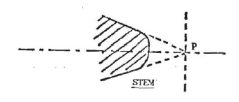

Point Q is similarly defined at the stern.

The distance between P and Q shall be 6700mm with a tolerance of 40mm.

**4. Building rule for Wooden Hulls**

**4.1. Frames**

The hull will be built using a set of seven moulding frames which should be set up on

a level surface.

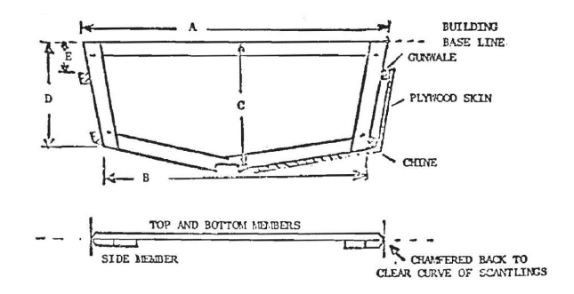

Note: It will be seen that the plywood is in contact with the moulding frames at the

bottom but not the sides.

Dimensions and positions of these moulding frames are given in the following table

of offsets:

**Table of Offsets** (in millimetres)

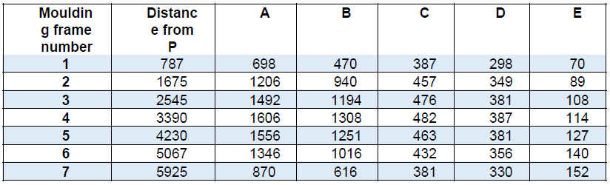

These measurements are given for guidance only and care must be taken in setting

up the moulding frames to obtain the correct hull shape. Gunwales and chines will

need to be about 32 mm x 25 mm before fairing off to give the correct hull

dimensions.

Note: The measurements given for positioning the moulding frames are taken at the

join between the side members and the top and bottom members

**4.2. Keel**

The keel shall not be more than 75 mm wide while the thickness should be between

25 mm and 22 mm along the centreline.

**4.3. Stem**

The stem shall be at an angle of approximately 45° to the base line.

**5. Measurement Rule**

**5.1. Method**

The hull shall be measured at the position of each moulding frame given in the

building rule for wooden hulls. This may be done by using a jig which can be bent to

the shape of the hull.

**5.2. Baseline**

The measuring baseline shall be determined as follows:

**At the bow**

203 mm below the keel at a point 457mm aft of a line perpendicular to the building

base line passing through the true bow (point P).

**At the stern**

203 mm below the keel at a point 152 mm forward of a line perpendicular to the

building base line passing through the true stern (point Q).

When determining these positions, measurements shall be taken from the line

formed by continuing the plane formed by the plywood/GRP on either side of the

keel as shown in the diagram.

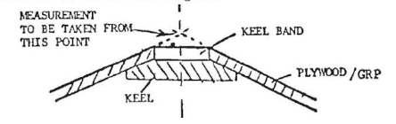

**Illustration to show baseline and measuring stations (see table below)**

**5.3. Measurements**

The measurements to be taken and the tolerances allowed are shown in the table

below.



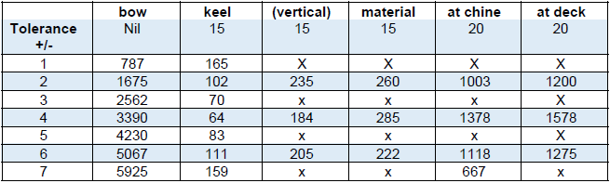

**Table of Measurements in millimeters**

*Note: These measurements shall be taken to the extremities of the hull or deck and*

*not to the rubbing strake if one is fitted. For moulded decks, a rubbing strake is*

*defined as that part of the deck moulding which extends beyond the plane of the hull*

*topsides.*

**5.4. Keel**

The keel band shall not project below the angle formed by the skin of the bottom on

either side except that a metal strip, not more than 5mm deep may be fitted along

the centreline of the hull and at the edges of the centreboard case and rudder box.

**5.5. Chines**

At the bow, the distance between the baseline and the centre of the chine shall be

370mm with a tolerance of plus or minus 15mm. (This measurement should be

correct if the chine meets the stem at a point 215mm down from the deck measured

along the stern).

At the stern, the distance between the base line and the centre of the chine shall be

a minimum of 267mm. At the join of the sternpost, the chine angle shall be 180

degrees, in other words there shall be no discontinuity between the sides and bottom

of the hull at this point (see diagram). The width of material forming the bottom chine

of the hull shall be not less than 50 mm at the join of the sternpost.

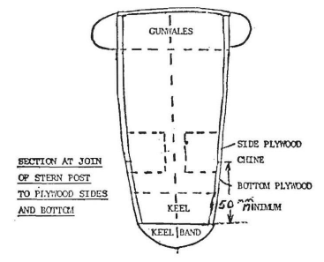

**5.6. Deck**

**5.6.1.**

The foredeck shall extend aft at least 4’ (1219mm) from the bow and be decked

between mast step and forestay bulkhead. No cut outs exceeding 450mm in length

or width are allowed in the foredeck between mast and forestay. The crop of the

foredeck shall not exceed 150 mm.

**5.6.2.**

The stern deck shall extend forward at least 2’ (610mm) from the stern. The deck

may be cut down at the stern, but the distance between the deck and the bottom of

the hull (excluding any metal strip) at a point 75 mm from the true stern (point Q)

shall be not less than 150 mm.

**5.6.3.**

The side deck width shall be maximum 1’ (305mm) excluding rubbing strake and

minimum 6” (152mm).

**5.6.4.**

The cockpit shall be at least 6’ (1829mm) in length.

**6. Sail Measurement**

A Mainsail and Jib must be used.

**6.1. Mainsail**

The mainsail shall comply with the Norfolk Punt Class Rules except that the luff

length shall not exceed 7950mm.

**6.2. Spinnaker**

The spinnaker shall comply with the Norfolk Punt Class Rules except it must not be

flown from a point on the mast greater than 6750mm from the top of the deck.